**Employee Engagement and Work-Life Balance Analysis**

**Executive Summary**

This report provides an in-depth analysis of the employee engagement and work-life balance metrics within the organization. Key performance indicators (KPIs) such as work-life balance, job involvement, relationship satisfaction, and overtime distribution have been assessed across various departments and job roles. The objective is to identify areas for improvement and recommend strategies to enhance overall employee satisfaction and productivity.

**Key Metrics**

1. **Average Work-Life Balance**: 2.76
2. **Average Job Involvement**: 2.73
3. **Average Relationship Satisfaction**: 2.71
4. **Overtime Distribution**:
   * Employees not working overtime: 71.70%
   * Employees working overtime: 28.30%

**Detailed Analysis**

**1. Work-Life Balance by Department**

* **Human Resources**: 2.92
* **Research & Development**: 2.73
* **Sales**: 2.82

**Visualization: Work-Life Balance by Department**

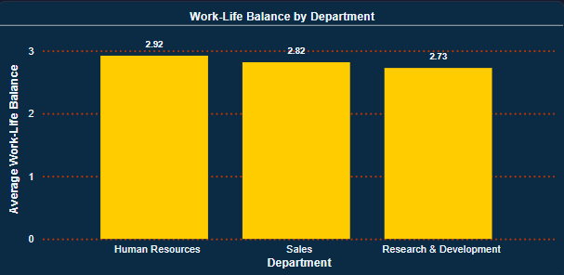

**2. Job Involvement by Department**

* **Human Resources**: 2.75
* **Research & Development**: 2.74
* **Sales**: 2.70

**Visualization: Job Involvement by Department**

**3. Relationship Satisfaction by Department**

* **Human Resources**: 2.89
* **Research & Development**: 2.71
* **Sales**: 2.70

**Visualization: Relationship Satisfaction by Department**

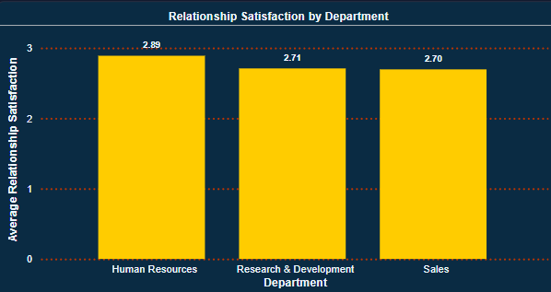

**4. Overtime Distribution**

* **No**: 71.70%
* **Yes**: 28.30%

**Visualization: Overtime Distribution**

**Areas for Improvement**

1. **Work-Life Balance**:
   * **Department**: Research & Development
   * **Strategy**: Implement flexible working hours to improve work-life balance.
2. **Job Involvement**:
   * **Department**: Sales
   * **Strategy**: Introduce job rotation programs to increase engagement.
3. **Relationship Satisfaction**:
   * **Department**: Sales
   * **Strategy**: Conduct team-building activities to foster better workplace relationships.
4. **Overtime**:
   * **Strategy**: Reduce overtime workload in research-focused roles and ensure balanced workload distribution.

**Recommended Strategies**

1. **Implement Flexible Working Hours**: In the Research & Development department to allow employees to better balance their work and personal life.
2. **Introduce Job Rotation Programs**: In the Sales department to increase engagement by providing diverse experiences and opportunities to learn new skills.
3. **Conduct Team-Building Activities**: In the Sales department to improve workplace relationships.
4. **Manage Overtime**: Assess workload and resource allocation for roles, especially in research-focused positions, to reduce excessive overtime.

**Conclusion**

This report highlights the key areas for improvement in work-life balance, job involvement, and relationship satisfaction within the organization. By implementing the recommended strategies and setting up regular monitoring through a Power BI dashboard, the organization can enhance overall employee satisfaction and productivity.